**EDU TUTOR AI: Personalized Learning**

**Project Documentation**

**1.Introduction**

**Project title: EDU TUTOR AI**

**Project Leader: S. SANJAY**

**Project Member: S. DEEPAK**

**Project Member: S. HARIHARAN**

**Project Member: J. GUNASEKARAN**

**2.project overview**

**Purpose:**

The purpose of a tutor, or”edu tutor,” is to provide personalized, one-to-one academic support to help students overcame challenges, enchance understanding, and develop independence in their learning. Tutors offer individualized explainations, create a safe space to ask questions, and tailor instructions to a student’s unique needs and learning style to ultimately foster academic confidence and self-sufficuiency.

**Conversational interface:**

**Key points: AI-Driven personalization**

EduTutor AI uses the Granite model from Hugging Face to create simple, personalized learning tools like concept explainers, quizzes generator and add more functionalities that you like. This project is deployed in Google Colab using Granite for low setup effort and reliable performance. Pre-requisites:

1. Gradio Framework Knowledge: Gradio Documentation

2. IBM Granite Models (Hugging Face): IBM Granite

3. Python Programming Proficiency: Python Documentation

4. Version Control with Git: Git Documentation

5. Google Collab’s T4 GPU Knowledge: Google collab

Functionality: An edu tutor conversational interface functions by engaging a students in a natural language dialogue .

Conversational user interfaces help humans interact with computers using or text as technology grows ,it is becoming easy to interpret human voice or text into an understandable computer format.

Scenario 1: Personalized Learning Experience

A student logs into EduTutor AI and synchronizes their courses using their Google Classroom credentials. The platform analyzes course data, generates quizzes on key topics using the Granite LLM, and assesses responses for instant feedback—creating a highly personalized and engaging learning journey.

Educator Dashboard & Performance Insights

Educators can log in to view real-time quiz performance of all students. The dashboard highlights quiz history, scores, last topics attempted, and insights fetched from the Pinecone vector database. This empowers teachers to monitor learning progress and personalize their instruction based on data.

Diagnostic Testing and Adaptive Quizzing

Upon registration, students undergo a diagnostic test generated by IBM Watsonx models. Based on the results, the platform adapts quiz difficulty and topic relevance, ensuring students are challenged at the right level.

Google Classroom Integration

EduTutor AI syncs courses directly from Google Classroom, allowing seamless access to student data, class names, and subjects. This enables automatic quiz topic generation and helps maintain consistent alignment with the academic curriculum.

User Input:

Students log in using credentials or Google Classroom and request a quiz by selecting topic and difficulty.

AI Quiz Generation:

Watsonx+Granite models generate MCQs, stored temporarily without answers in the frontend and with answers in the backend

User Quiz Submission:

Students submit answers via UI. The backend evaluates the answers, scores the quiz, and stores it in Pinecone DB.But Some errors couldnt built the frontend part.

Screenshots:

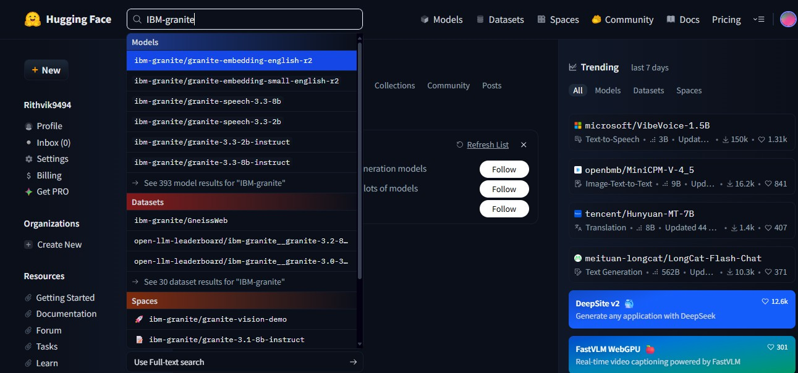

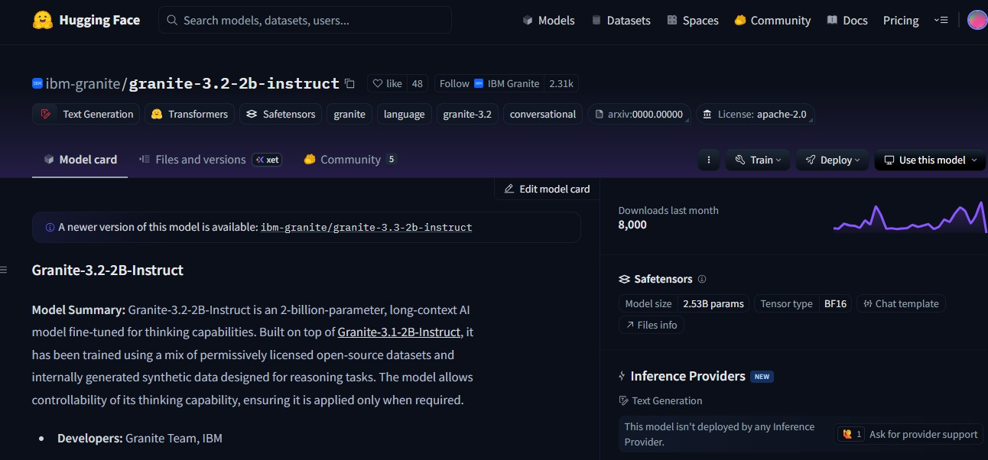

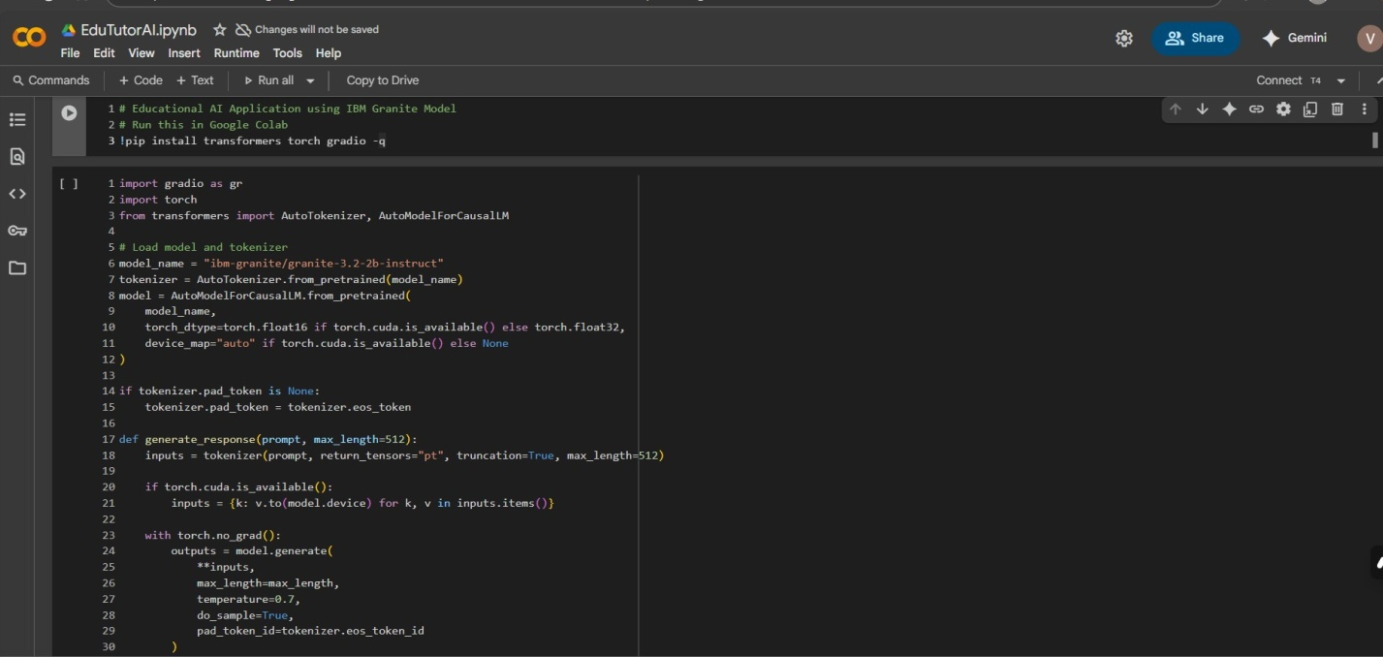

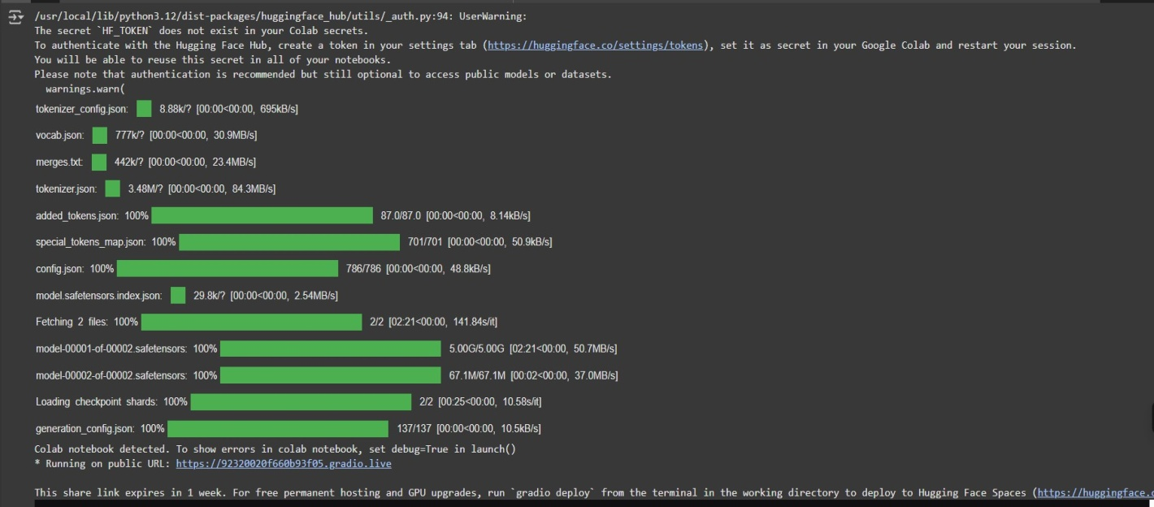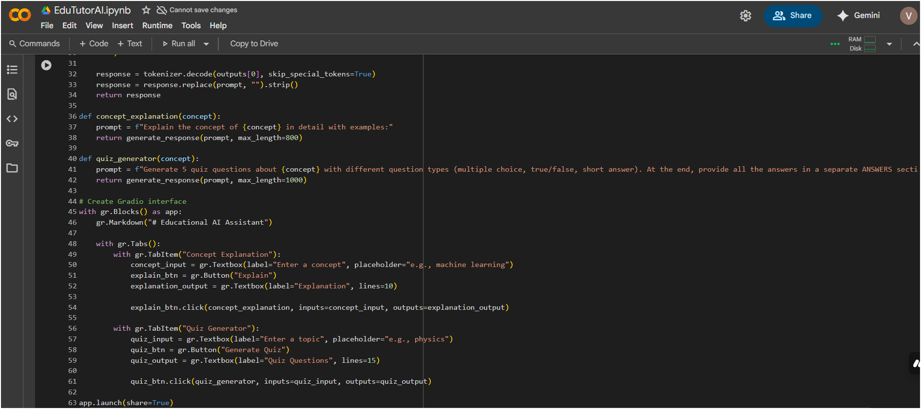

**Conclusions**

An AI tutor project conclusion should highlight that the technology is a powerful tool for personalized and accessible learning, but also acknowledge its limitations in fostering human elements like empathy and creativity, advocating for a hybrid model where AI enhances and collaborates with human teachers. Future directions involve further development of AI capabilities through advancements in machine learning and natural language processing, integration with immersive technologies like VR/AR, and continued focus on responsible development to address ethical considerations and ensure equitable access to high-quality education for all students.